- Launch the services manager by browsing to Start | Control Panel | Administrative Tools | Services. Double click on the Services icon to open the Services dialog.
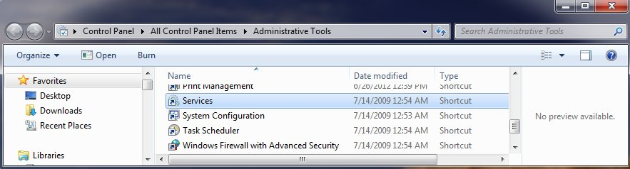
- Sort by name and locate OmniServer in the list. It should show up as “ OmniServer by Software Toolbox”
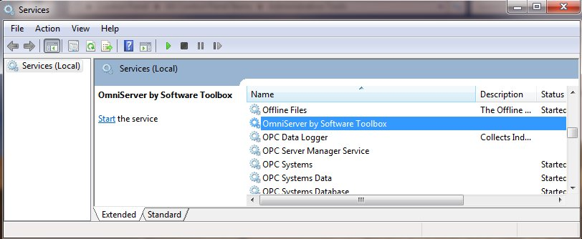

- Right click on the service name and select Properties
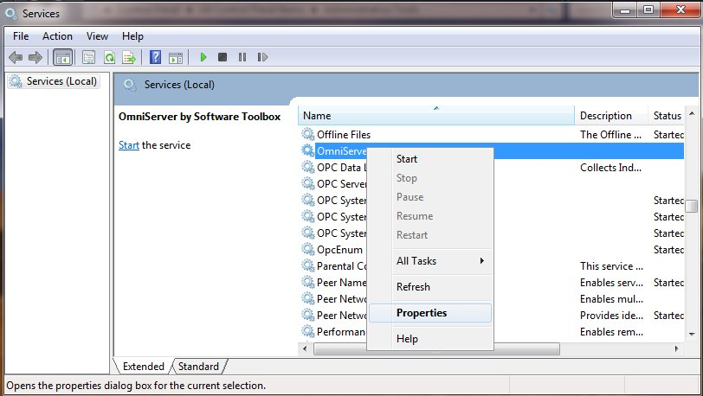

- Click on the Recovery Tab
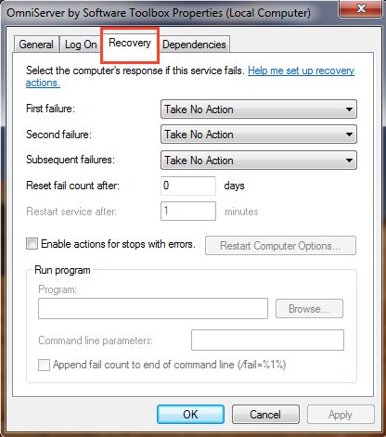

- Set the following properties:

  - First Failure: Restart the Service
  - Second Failure: Restart the Service
  - Subsequent Failures: Restart the Service
  - Reset fail count after: 0 days
  - Restart Service after: 1 minute

The tab should look like the screenshot below.
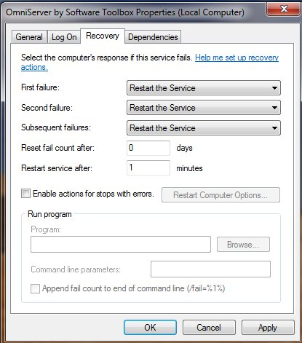

- Click the Apply button. Then click Ok.
